Name : Parthib Kumar Das , Enrollment No: 12023052002018 , CSE , Roll No: 18

Institute of Engineering & Management, Kolkata

Email ID: PARTHIBKUMAR.DAS2023@iem.edu.in

Dasparthib111@gmail.com

Video Demonstration Link : https://www.loom.com/share/2214052a281d40c88c8ea59d2a89a349

Module Name : Unit Test Frameworks

Experiment Title : Radio Button

Problem Statement
To identify and interact with radio buttons on a webpage using Selenium WebDriver and verify the selection of the required option.

Objective
To learn how to locate, select, and verify radio buttons using Selenium WebDriver.

Tools, Software, and Concepts Used
- Python 3.x
- Selenium (latest version)
- Google Chrome / Mozilla Firefox
- Selenium WebDriver
- VS Code / PyCharm
- Python packages:
  - selenium
  - webdriver-manager
- Concepts: Radio Button, Web Element Identification, click(), is_selected(), Locators

Source Code / Implementation Steps
- Install Selenium and WebDriver Manager.
- Import the required Selenium modules.
- Launch the browser using Selenium WebDriver.
- Open the required webpage.
- Locate the radio button using a suitable locator.
- Click the radio button using the click() method.
- Verify whether the radio button is selected using is_selected().
- Close the browser using driver.quit().
Source Code :
from selenium import webdriver
from selenium.webdriver.common.by import By
from selenium.webdriver.chrome.service import Service as ChromeService
from selenium.webdriver.chrome.options import Options as ChromeOptions
from webdriver_manager.chrome import ChromeDriverManager
import time
# Chrome Options
chrome_options = ChromeOptions()
# Chrome Service
chrome_service = ChromeService(
ChromeDriverManager().install()
)
# Start Chrome
driver = webdriver.Chrome(
service=chrome_service,
options=chrome_options
)
# Open website
driver.get("https://rahulshettyacademy.com/AutomationPractice/")
time.sleep(3)
# Radio 1
radio1 = driver.find_element(By.XPATH, "//input[@value='radio1']")
radio1.click()
time.sleep(2)
print("Radio 1 selected:", radio1.is_selected())
time.sleep(3)
driver.quit()
Output with clearly labelled screenshots :
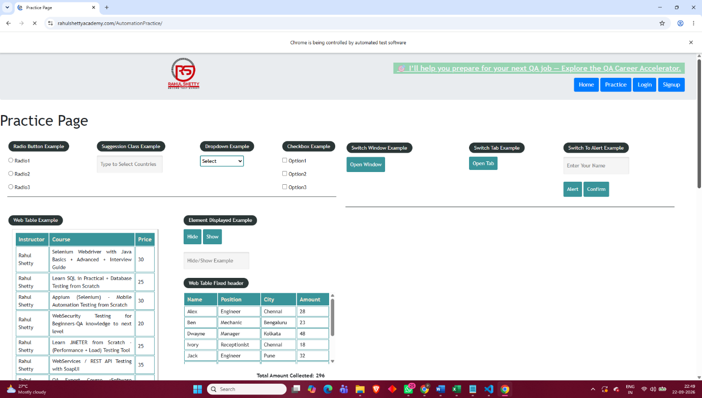

Result: The required radio button was successfully identified and selected.
Observation: The click() method selects the radio button, while is_selected() verifies its selection status.
Conclusion: The experiment demonstrated how to automate and verify radio button selection using Selenium WebDriver.

Experiment Title : Keyboard Actions

Problem Statement
To identify and perform keyboard actions on web elements using Selenium WebDriver, such as typing, pressing keys, copying, pasting, and using keyboard shortcuts.

Objective
To learn how to automate keyboard operations on web pages using Selenium WebDriver and the Keys class.

Tools, Software, and Concepts Used
- Python 3.x
- Selenium (latest version)
- Google Chrome / Mozilla Firefox
- Selenium WebDriver
- VS Code / PyCharm
- Python packages:
  - selenium
  - webdriver-manager
- Concepts: Keyboard Actions, Keys class, send_keys(), Keyboard Shortcuts, Web Elements

Source Code / Implementation Steps
- Install Selenium and WebDriver Manager.
- Import the required Selenium modules and Keys class.
- Launch the browser using Selenium WebDriver.
- Open the required webpage.
- Locate the required input or web element.
- Use send_keys() to perform keyboard actions.
- Use keys such as ENTER, TAB, CTRL, SHIFT, and BACKSPACE as required.
- Verify the performed actions and close the browser using driver.quit().
Source Code :
from selenium import webdriver
from selenium.webdriver.common.by import By
from selenium.webdriver.chrome.service import Service as ChromeService
from selenium.webdriver.chrome.options import Options as ChromeOptions
from selenium.webdriver.common.keys import Keys
from webdriver_manager.chrome import ChromeDriverManager
import time
# Chrome Options
chrome_options = ChromeOptions()
# Chrome Service
chrome_service = ChromeService(
ChromeDriverManager().install()
)
# Start Chrome
driver = webdriver.Chrome(
service=chrome_service,
options=chrome_options
)
# Open website
driver.get("https://rahulshettyacademy.com/AutomationPractice/")
time.sleep(3)
# Find Name field
name = driver.find_element(By.ID, "name")
# Type text
name.send_keys("Parthib Kumar Das")
time.sleep(2)
# Select all text
name.send_keys(Keys.CONTROL, "a")
time.sleep(2)
# Delete selected text
name.send_keys(Keys.BACKSPACE)
time.sleep(2)
# Type new text
name.send_keys("Selenium Tester")
time.sleep(3)
driver.quit()
Output with clearly labelled screenshots :
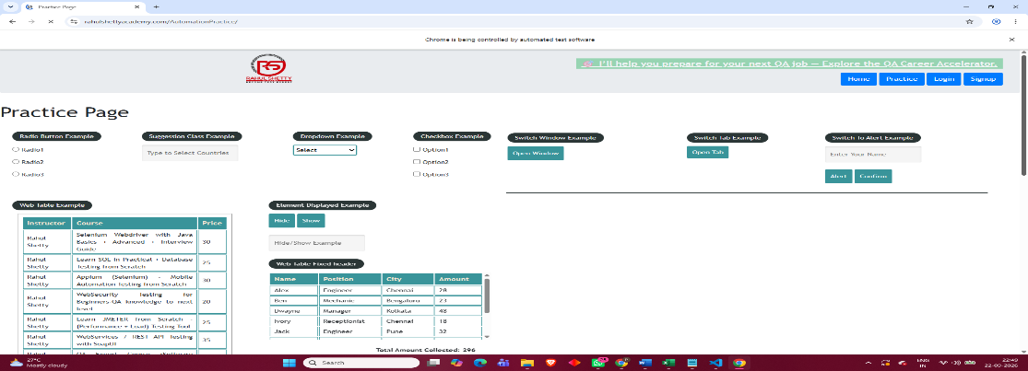
Result: Keyboard actions were successfully performed on the web elements using Selenium.
Observation: Selenium's Keys class allows automation of keyboard keys and shortcuts through the send_keys() method.
Conclusion: The experiment demonstrated how keyboard operations can be automated efficiently using Selenium WebDriver.

Experiment Title : Mouse Hover

Problem Statement
To identify a web element and perform a mouse hover action on it using Selenium WebDriver to access or display hidden menus and options.

Objective
To learn how to perform mouse hover actions on web elements using Selenium's ActionChains class.

Tools, Software, and Concepts Used
- Python 3.x
- Selenium (latest version)
- Google Chrome / Mozilla Firefox
- Selenium WebDriver
- VS Code / PyCharm
- Python packages:
  - selenium
  - webdriver-manager
- Concepts: Mouse Hover, ActionChains, Web Element Identification, move_to_element()

Source Code / Implementation Steps
- Install Selenium and WebDriver Manager.
- Import Selenium and the ActionChains class.
- Launch the browser using Selenium WebDriver.
- Open the required webpage.
- Locate the element on which the mouse hover action is required.
- Create an ActionChains object.
- Use move_to_element() to move the mouse over the selected element.
- Perform the action and verify the displayed menu or option.
- Close the browser using driver.quit().
Source Code:
from selenium import webdriver
from selenium.webdriver.common.by import By
from selenium.webdriver.chrome.service import Service as ChromeService
from selenium.webdriver.chrome.options import Options as ChromeOptions
from selenium.webdriver.common.action_chains import ActionChains
from webdriver_manager.chrome import ChromeDriverManager
import time
# Chrome Options
chrome_options = ChromeOptions()
# Chrome Service
chrome_service = ChromeService(
ChromeDriverManager().install())
# Start Chrome
driver = webdriver.Chrome(
service=chrome_service,
options=chrome_options)
# Open website
driver.get("https://rahulshettyacademy.com/AutomationPractice/")
time.sleep(3)
# Find Mouse Hover button
mouse_hover = driver.find_element(By.ID, "mousehover")
# Create ActionChains
actions = ActionChains(driver)
# Move mouse over the button
actions.move_to_element(mouse_hover).perform()
# Wait so you can see the hidden menu
time.sleep(3)
# Close browser
driver.quit()
Output with clearly labelled screenshots :
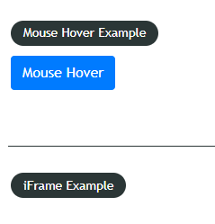
Result: The mouse hover action was successfully performed on the selected web element.
Observation: ActionChains and move_to_element() are used to simulate mouse movement and hover actions.
Conclusion: The experiment demonstrated how Selenium can automate mouse hover interactions on web pages.

Experiment Title : Alerts

Problem Statement
To identify, handle, and interact with JavaScript alert pop-ups on a webpage using Selenium WebDriver.

Objective
To learn how to handle different types of alerts such as Simple Alert, Confirmation Alert, and Prompt Alert using Selenium WebDriver.

Tools, Software, and Concepts Used
- Python 3.x
- Selenium (latest version)
- Google Chrome
- Selenium WebDriver
- VS Code / PyCharm
- Python packages:
  - selenium
  - webdriver-manager
- Concepts: Alerts, switch_to.alert, accept(), dismiss(), send_keys(), text
The given practice website contains Simple Alert, Confirmation Alert, and Prompt Alert buttons.

Source Code / Implementation
from selenium import webdriver
from selenium.webdriver.chrome.service import Service
from selenium.webdriver.common.by import By
from webdriver_manager.chrome import ChromeDriverManager
import time
service = Service(ChromeDriverManager().install())
driver = webdriver.Chrome(service=service)
driver.get("https://testautomationpractice.blogspot.com/")
driver.maximize_window()
time.sleep(2)
# ---------------- Simple Alert ----------------
driver.find_element(By.XPATH, "//button[text()='Simple Alert']").click()
time.sleep(1)
alert = driver.switch_to.alert
print("Simple Alert:", alert.text)
alert.accept()
time.sleep(2)
# ---------------- Confirmation Alert ----------------
driver.find_element(By.XPATH, "//button[text()='Confirmation Alert']").click()
time.sleep(1)
alert = driver.switch_to.alert
print("Confirmation Alert:", alert.text)
alert.accept()
time.sleep(2)
# ---------------- Prompt Alert ----------------
driver.find_element(By.XPATH, "//button[text()='Prompt Alert']").click()
time.sleep(1)
alert = driver.switch_to.alert
print("Prompt Alert:", alert.text)
alert.send_keys("Parthib")
alert.accept()
time.sleep(2)
driver.quit()
Output with clearly labelled screenshots :
Result: Different types of alerts were successfully identified and handled using Selenium WebDriver.
Observation: Selenium uses switch_to.alert to interact with JavaScript alerts and provides methods such as accept(), dismiss(), and send_keys().
Conclusion: The experiment demonstrated how to automate and handle Simple, Confirmation, and Prompt alerts using Selenium WebDriver.

